**Wireless Propagation:**

Wireless propagation is the movement of these radio waves (which move at the speed of light) to and from these sites and devices.

**Modes of Wireless Propagation:**

1. **Ground wave propagation:**

* waves follow contour/curvature of the Earth, this is due to EM waves induce current in the earth's surface.
* Frequency up to 2 MHz.
* Example:  AM radio broadcasting, direction finding.

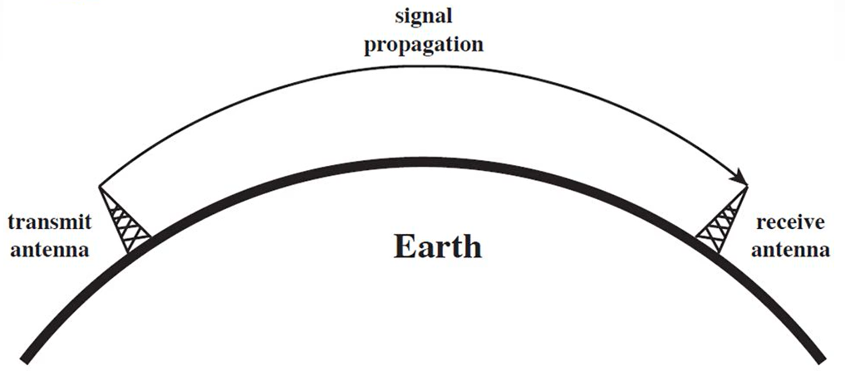

1. **Sky wave propagation:**

* Here ionosphere above earth's surface reflect the transmitted wave and hence it gets propagated due to reflection.
* Frequency between 2 MHz and 30 MHz.
* Example: amateur radio, international broadcasting, military communication.

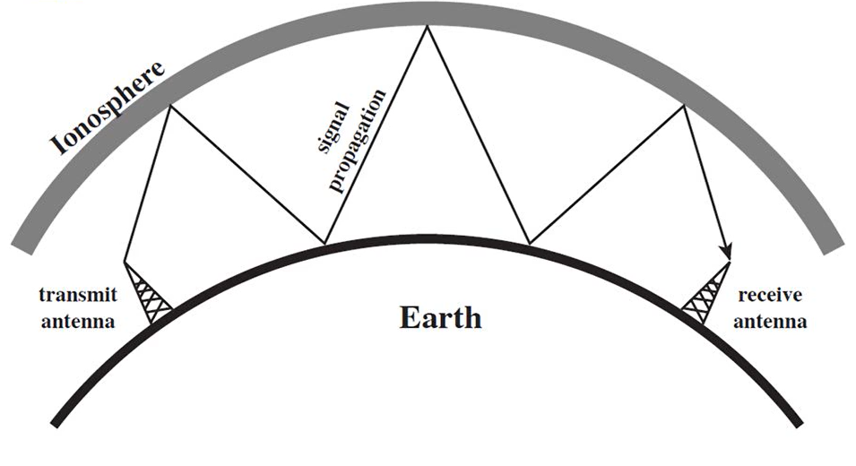

1. **Line-of-Sight propagation:**

* For satellite application, it is transmitted from earth station antenna to the satellite antenna.
* For ground based wireless link, communication happens when both the transmitter and receiver antennas are in the line of sight of each other.
* Frequency above 30 MHz.
* Example; FM broadcast, cellular telecom.

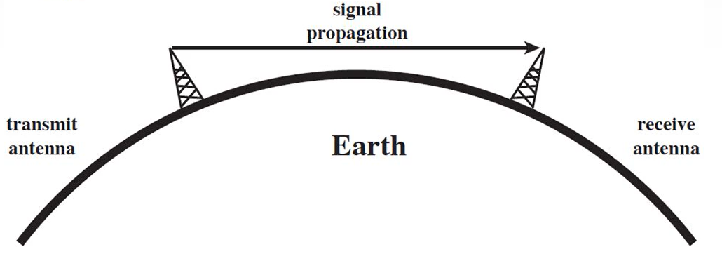

**Line-of-Sight Equation:**

* With no intervening obstacles, the optical line of sight can be expressed as

**d = 3.57 √h**

Where

* d = distance between antenna and the horizon(Km)
* h = height of antenna(m).

**Wireless Propagation Characteristics:**

1. **Path Loss:**

* Path loss (PL) refers to the loss or attenuation a propagating electromagnetic signal (or wave) encounters along its path from transmitter to the receiver.
* The received power level is dependent on factors such as transmission power, antenna gains, frequency of operation and the distance between the transmitter and the receiver.

1. **Shadowing:**

* Shadowing is caused by obstacles between the transmitter and receiver that attenuate signal power through absorption, reflection, scattering, and diffraction.

1. **Multipath fading:**

* In multipath propagation, multiple signal paths are established between the base station and the user terminal. The fading due to multipath propagation is known as Multipath fading.

